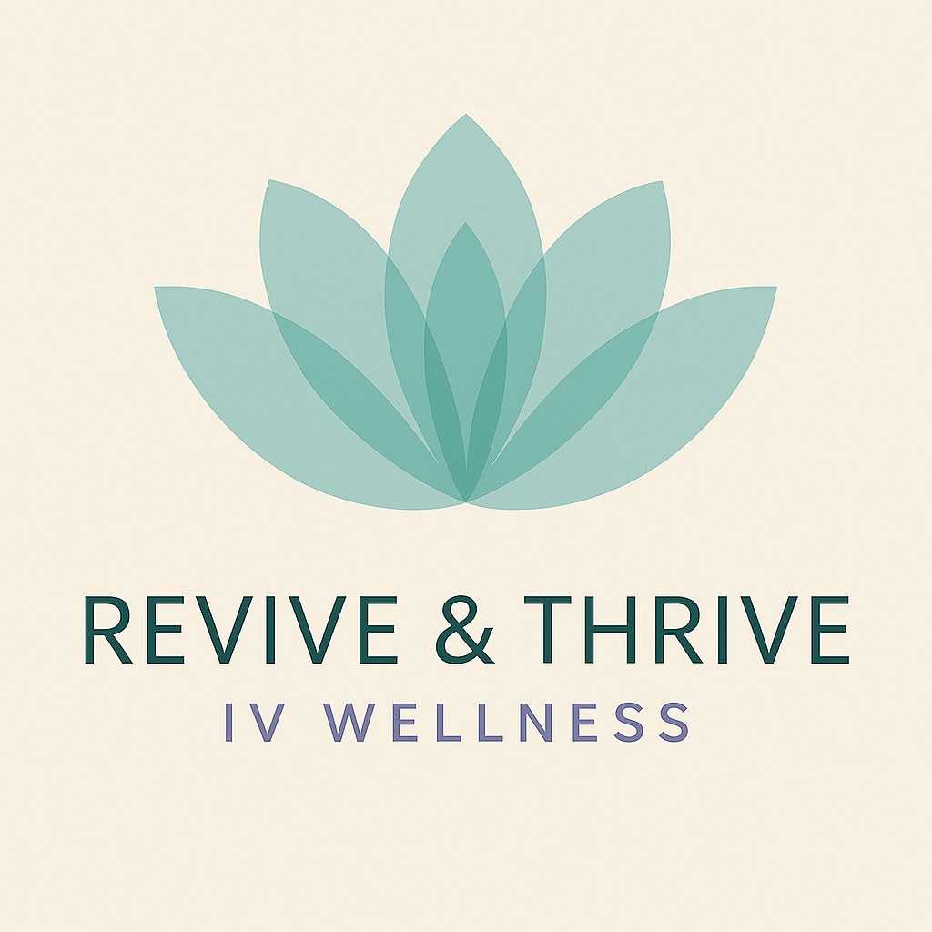

Medical Disclaimer
Revive & Thrive IV Wellness LLC
The information, services, and products provided by Revive & Thrive IV Wellness LLC are intended for general wellness purposes only and are not intended to diagnose, treat, cure, or prevent any medical condition or disease. All content, including text, graphics, images, and information, contained on or available through our website, marketing materials, or services, is for informational purposes only.
Our IV hydration therapy, wellness injections, and related services are not a substitute for professional medical advice, diagnosis, or treatment. Always seek the advice of your physician or other qualified healthcare provider with any questions you may have regarding a medical condition.
By receiving services from Revive & Thrive IV Wellness LLC, you acknowledge and understand that:
- You are receiving elective wellness services at your own request.
- Our services are not intended to replace the relationship you have with your primary care provider.
- You should consult with a healthcare professional before beginning any new treatment, especially if you have any health conditions or are taking medications.
If you are experiencing a medical emergency, call 911 or go to the nearest emergency room immediately.
Revive & Thrive IV Wellness LLC and its staff make no representations or warranties regarding the efficacy, safety, or outcomes of the services provided. Use of our services is at your own risk.

